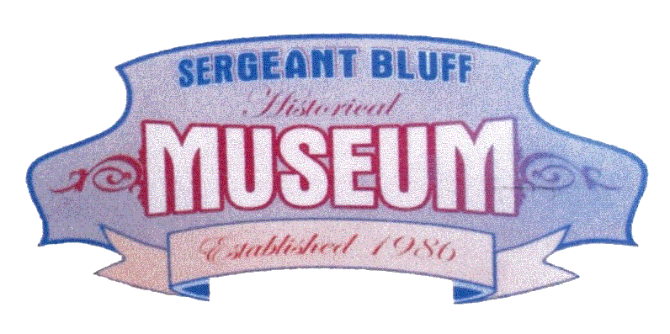
In order to preserve your family history while living in Sergeant Bluff, the Sergeant Bluff Historical
Society is in the process of updating and creating family histories. These family histories will be
filed at the Sergeant Bluff Historical Museum for future generations to observe and research. We
are asking each citizen to complete the following outline:

Husband's full name:
Date of birth: |  |  | Location of birth:
Date of marriage: |  |  | Location of marriage:
Current place of residency:
Previous cities of residency:
Year you moved to Sgt. Bluff:
School of graduation:
Occupations:
Religion:
Military:
His father & mother:
Their dates of birth: |  |  | Locations of birth:
Their date of marriage: |  |  | Location of marriage:
Relatives in Sgt. Bluff:
Wife's full name:
Date of birth: |  |  | Location of birth:
Date of marriage: |  |  | Location of marriage:
Current place of residency:
Previous cities of residency:
Year you moved to Sgt. Bluff:
School of graduation:
Occupations:
Religion:
Military:
Her father & mother:
Their dates of birth: |  |  | Locations of birth:
Their date of marriage: |  |  | Location of marriage:
Relatives in Sgt. Bluff:
Children's names:
Dates of birth:
Locations of birth:
Family memories of Sgt. Bluff:
Events that happened here:
Volunteering in community:

If needed, please feel free to use an additional page for your information.

Please feel free to include photos (family or places), family tree, or any other information.

Please return this form to the museum at 409 4th St on Saturday mornings 9-1 or mail it to the Sergeant Bluff Historical Society at PO Box 203 Sergeant Bluff, IA 51054.

